WD-ACTIVITY BASED LEARING

NAME : GONEPALLI AKSHAYA
REGISTER NUMBER : 26001584
SECTION : AIML-1
  - CASE:2
Design a college website displaying institutional information, departments, courses, faculty profiles, admissions procedures, campus facilities, events, and contact details. Create a navigation bar, banner, and responsive information cards.
Input (code) :
<!DOCTYPE html>
<html>
<head>
<title>My College</title>

<style>
body {
font-family: Arial;
text-align: center;
background-color: #f5f0fa;
}

h1 {
background-color: purple;
color: white;
padding: 20px;
}

nav {
background-color: #250044;
padding: 15px;
}

a {
color: white;
text-decoration: none;
margin: 10px;
}

.banner {
background-color: #d9c2f0;
padding: 30px;
}

.card {
background-color: white;
border: 2px solid purple;
border-radius: 10px;
padding: 10px;
margin: 15px;
}

h2 {
color: purple;
}
</style>
</head>

<body>

<h1>DR.RVR NRI UNIVERSITY</h1>

<nav>
<a href="#home">Home</a>
<a href="#about">About</a>
<a href="#courses">Courses</a>
<a href="#contact">Contact</a>
</nav>

<div class="banner" id="home">
<h2>Welcome to Our College</h2>
<p>Learn Today, Lead Tomorrow</p>
</div>

<h2 id="about">About Us</h2>
<p>Our college provides quality education to students.</p>

<h2 id="courses">Our Courses</h2>

<div class="card">
<h3>CSE</h3>
<p>Computer Science Engineering</p>
</div>

<div class="card">
<h3>AIML</h3>
<p>Artificial Intelligence and Machine Learning</p>
</div>

<h2>Facilities</h2>
<p>Library | Labs | Sports | Transport</p>

<h2>Admissions and Events</h2>
<p>Admissions, Workshops and College Fest</p>

<h2 id="contact">Contact Us</h2>
<p>Agiripalli, Andhra Pradesh</p>

<footer>
<p>© 2026 My College Website</p>
</footer>

</body>
</html>

Output :
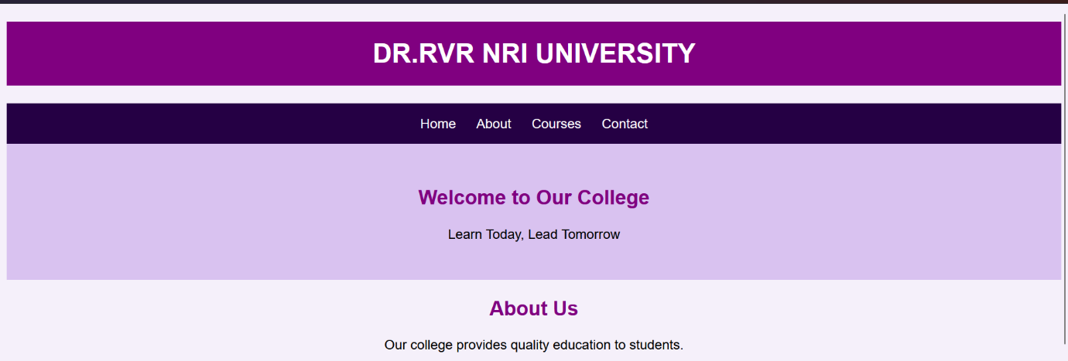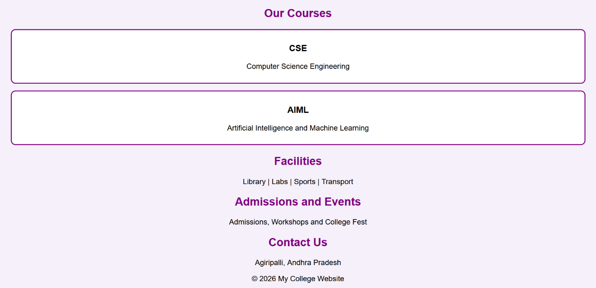

CASE : 6
Create an e-commerce interface displaying products, prices, discounts, ratings, categories, product descriptions, and shopping buttons. Design a responsive product grid, promotional banners, and a shopping navigation bar.

Input(code) :
<!DOCTYPE html>
<html>
<head>
<title>Akshaya's Shopping Website</title>

<style>
body {
font-family: Arial;
text-align: center;
margin: 0;
background: #f5f5f5;
}

h1 {
background: #4b0082;
color: white;
padding: 20px;
margin: 0;
}

nav {
background: #250044;
padding: 15px;
}

nav a {
color: white;
text-decoration: none;
margin: 10px;
}

.banner {
background: #fce4ec;
padding: 25px;
color: #8e2454;
}

.products {
display: flex;
flex-wrap: wrap;
justify-content: center;
}

.card {
background: white;
width: 220px;
margin: 15px;
padding: 12px;
border-radius: 10px;
}

.card img {
width: 100%;
height: 170px;
object-fit: cover;
}

button {
background: purple;
color: white;
padding: 10px;
border: none;
border-radius: 5px;
}

footer {
background: #250044;
color: white;
padding: 12px;
}
</style>
</head>

<body>

<h1>Akshaya's Shopping Store</h1>

<nav>
<a href="#home">Home</a>
<a href="#products">Products</a>
<a href="#offers">Offers</a>
<a href="#contact">Contact</a>
</nav>

<div class="banner" id="home">
<h2>Big Shopping Sale!</h2>
<p>Up to 50% OFF on Selected Products</p>
</div>

<h2 id="products">Our Products</h2>

<div class="products">

<div class="card">
<img src="https://images.unsplash.com/photo-1505740420928-5e560c06d30e?w=400">
<h3>Headphones</h3>
<p>Category: Electronics</p>
<p>₹999 <del>₹1499</del></p>
<p>⭐ 4.5 Rating</p>
<p>Good sound quality headphones.</p>
<button>Add to Cart</button>
</div>

<div class="card">
<img src="https://images.unsplash.com/photo-1542291026-7eec264c27ff?w=400">
<h3>Sports Shoes</h3>
<p>Category: Fashion</p>
<p>₹1299 <del>₹1999</del></p>
<p>⭐ 4.3 Rating</p>
<p>Comfortable shoes for daily use.</p>
<button>Add to Cart</button>
</div>

<div class="card">
<img src="https://images.unsplash.com/photo-1523275335684-37898b6baf30?w=400">
<h3>Wrist Watch</h3>
<p>Category: Accessories</p>
<p>₹799 <del>₹1199</del></p>
<p>⭐ 4.2 Rating</p>
<p>Stylish watch for everyday wear.</p>
<button>Add to Cart</button>
</div>

</div>

<div class="banner" id="offers">
<h2>Special Offers!</h2>
<p>Shop Your Favourite Products Today</p>
</div>

<h2 id="contact">Contact Us</h2>
<p>Email: myshop@example.com</p>

<footer>
Akshaya's Shopping Store © 2026
</footer>

</body>
</html>

Output :

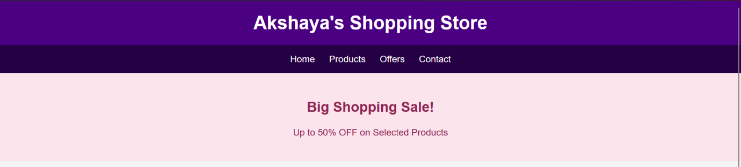
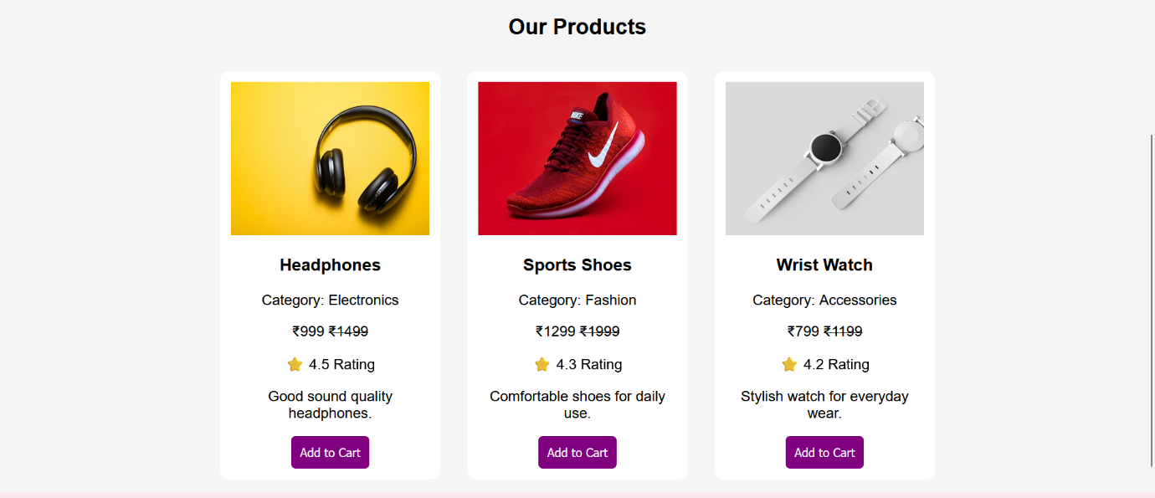
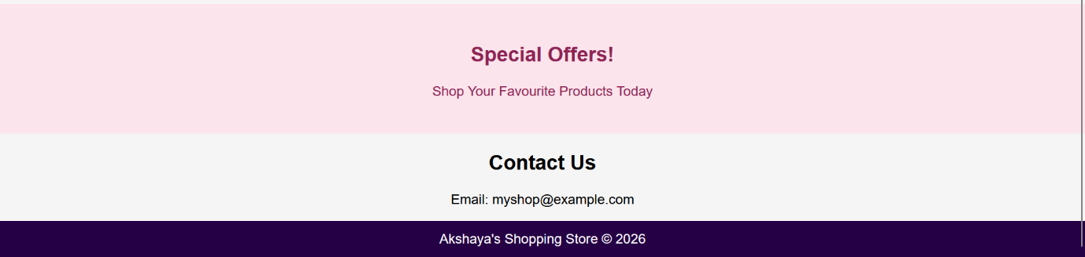

Case : 9
Create a website for a bakery displaying cakes, pastries, cookies, custom cake designs, product prices, seasonal offers, and store contact details. Use a visually appealing color scheme and image galleries.

Input(code):
<!DOCTYPE html>
<html>
<head>
<title> BUDDI'S Sweet Bakery</title>

<style>
body {
font-family: Arial;
margin: 0;
text-align: center;
background: #fff8f0;
}

header {
background: #713b32;
color: white;
padding: 20px;
}

nav {
background: #4b2924;
padding: 15px;
}

nav a {
color: white;
text-decoration: none;
margin: 10px;
}

.banner {
background: #f8d9dc;
color: #713b32;
padding: 35px 10px;
}

.products {
display: flex;
flex-wrap: wrap;
justify-content: center;
}

.card {
background: white;
width: 220px;
margin: 15px;
padding: 12px;
border-radius: 12px;
box-shadow: 0 3px 8px #ddd;
}

.card img {
width: 100%;
height: 170px;
object-fit: cover;
border-radius: 8px;
}

button {
background: #a34f5b;
color: white;
padding: 10px;
border: none;
border-radius: 5px;
}

h2 {
color: #713b32;
}

footer {
background: #4b2924;
color: white;
padding: 15px;
}
</style>
</head>

<body>

<header>
<h1>🍰BUDDI'S Sweet Bakery</h1>
<p>Freshly Baked with Love!</p>
</header>

<nav>
<a href="#home">Home</a>
<a href="#cakes">Cakes</a>
<a href="#offers">Offers</a>
<a href="#contact">Contact</a>
</nav>

<div class="banner" id="home">
<h2>Make Every Moment Sweet!</h2>
<p>Delicious Cakes, Pastries and Cookies</p>
<h3>🎉 Special Offer: 20% OFF</h3>
</div>

<h2 id="cakes">Our Bakery Items</h2>

<div class="products">

<div class="card">
<img src="https://images.unsplash.com/photo-1578985545062-69928b1d9587?w=400">
<h3>Chocolate Cake</h3>
<p>Rich and creamy birthday cake.</p>
<p>₹599 <del>₹799</del></p>
<button>Order Now</button>
</div>

<div class="card">
<img src="https://images.unsplash.com/photo-1488477181946-6428a0291777?w=400">
<h3>Pastry</h3>
<p>Soft and delicious sweet treat.</p>
<p>₹80 <del>₹100</del></p>
<button>Order Now</button>
</div>

<div class="card">
<img src="https://images.unsplash.com/photo-1499636136210-6f4ee915583e?w=400">
<h3>Cookies</h3>
<p>Crunchy chocolate chip cookies.</p>
<p>₹150 <del>₹180</del></p>
<button>Order Now</button>
</div>

<div class="card">
<img src="https://images.unsplash.com/photo-1550617931-e17a7b70dce2?w=400">
<h3>Cupcakes</h3>
<p>Beautiful cupcakes for every occasion.</p>
<p>₹60 each</p>
<button>Order Now</button>
</div>

</div>

<h2>Custom Cake Designs</h2>
<p>Birthday cakes | Wedding cakes | Anniversary cakes</p>

<div class="banner" id="offers">
<h2>🎁 Seasonal Offers</h2>
<p>Celebrate your special days with Sweet Bakery!</p>
</div>

<h2 id="contact">Contact Us</h2>
<p>📍 Address: Add your bakery address</p>
<p>📞 Phone: Add your contact number</p>
<p>✉️ Email: buddisweetbakery@example.com</p>

<footer>
<p>© 2026 Sweet Bakery</p>
<p>Made with ❤️</p>
</footer>

</body>
</html>

Output :

